Lab3: Using Pandas for Machine Learning

Student Number: 041067235
Student Name: Andrianna Wardill
Using Lab3.ipynb file answer the following Questions. Submit the word document with screenshots and answer to each question

Sample Output:
Q1. Whose name is assigned to the 0th index in the dataframe (Sample Output)?
First Show your Notebook Code with your name
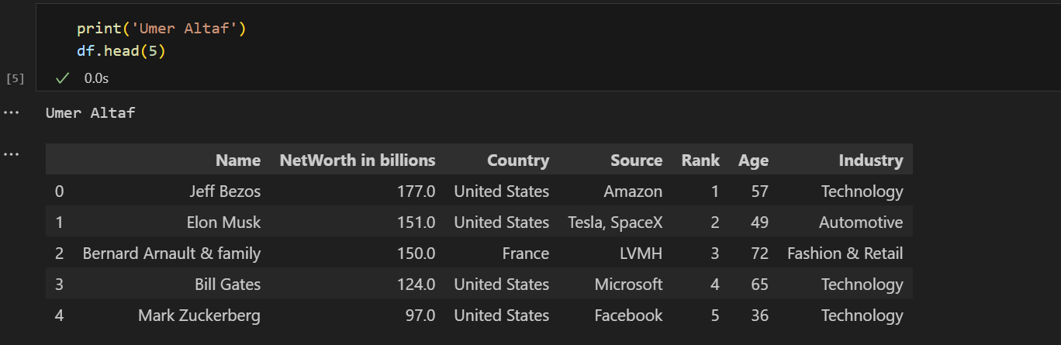
Answer to Q1: Jeff Bezos

Q1. Whose name is assigned to the 0th index in the dataframe (Sample Output)?
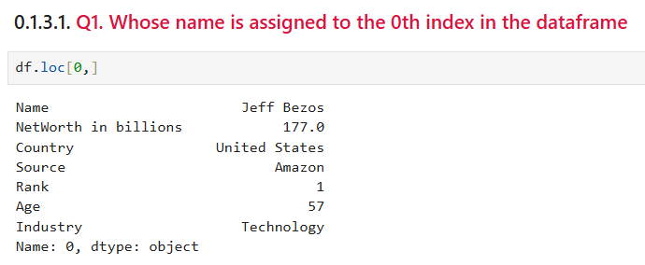
Jeff Bezos
Q2. How many records do you have in this dataset?
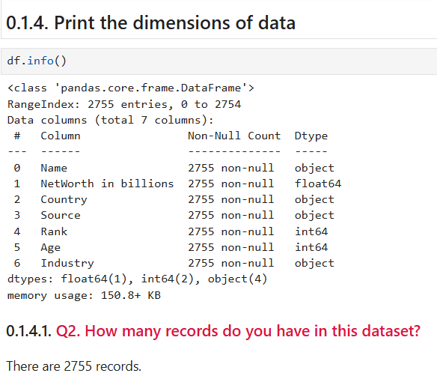
Q3. What is the data type of the variable Source
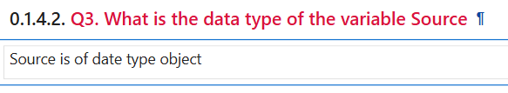
Q4. How many missing values exists in the industry feature
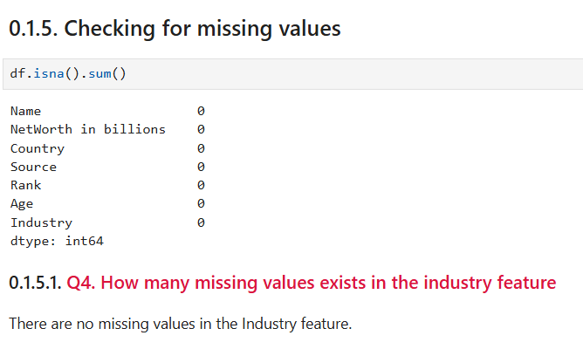
Q5. Who is the yongest billionare in this list?
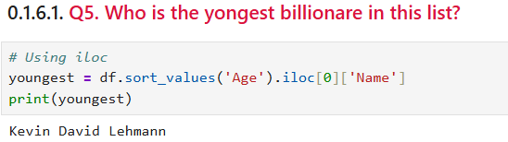
Q6. What is the output of `df.iloc[1200,3]?
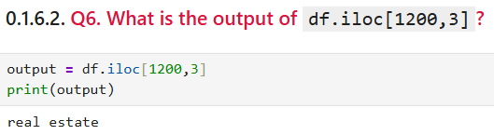
Q7. How many Billionaires were born in 1996?
